 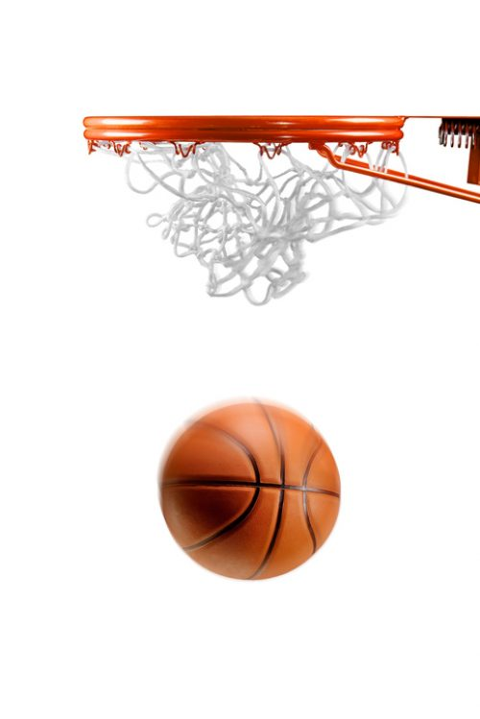

**2018 Summer Boys Basketball League**

**Division II (incoming 4th & 5th Graders)**

The San Francisco Associates organization and the Center (JCCCNC) are hosting a boy’s summer basketball league for current members and interested youths. All teams will be coached by volunteers and all participants will receive a t-shirt or jersey.

|  |  |
| --- | --- |
| **LEAGUE DATES:** | **June 8th, 15th, 22nd, 29th**  Friday nights: 6:30pm, 7:30pm, 8:30pm  **Saturday, June 23 – 2:30-5:30 pm**  **Friday, July 6th – Playoff/Championship (top 4 teams only)**  *dates and times are subject to change |
| **GAMES:** | Each team will have: 1-2 games/day  5-8 games depending on the # of teams |
| **LOCATION:** | The Center at 1840 Sutter Street, San Francisco, CA 94115 |
| **TEAM FORMATION:** | After the first week of games, players may be moved around to even out teams. |
| **ONLINE APPLICATION:**    **DEADLINE:** | <https://goo.gl/forms/3xuciddSxhRJSVy23>  Friday, May 11th *spots are limited, first come first served  Check application and payment status at  https://docs.google.com/spreadsheets/d/1BWGD0CwiKOYJMjZtrUZMvuyZEeVVM-1vMZh9JOWOwzk/edit?usp=sharing |
| **FEE:**  **MAIL PAYMENT:** | JCCCNC Members/Associates Members $50  Non Members $75  Please make checks payable to S.F. Associates  S.F. Associates  c/o Remi Nakamoto  14 Encanto Ave  SF CA 94115 |

**QUESTIONS: Remi Nakamoto at reminash@hotmail.com**